Notes 05 - Customzing ggplot2 Graphs

STS 2300 (Fall 2024)

Updated: 2024-09-21

Table of Contents

Reading for Notes 05 1

Learning Goals for Notes 05 1

Customizing graph titles, captions, and variable labels 2

Editing graph scales 3

Color schemes and graph themes 7

Images with multiples graphs 9

Revisiting the Learning Goals for Notes 05 11

# Reading for Notes 05

[Chapter 11](https://r4ds.hadley.nz/communication) of R for Data Science is a good resource for this section. In particular:

* section 11.2 talks about adding labels to your graph,
* section 11.4 goes into more detail about controlling scales, and
* section 11.5 includes information about customizing themes.

# Learning Goals for Notes 05

* Be able to customize graph titles, captions, and variable labels.
* Be able to edit the scales of your graphs to improve the visual appeal and to better convey information.
* Be able to customize color schemes and aspects of a graph’s theme
* Be able to create images containing multiple graphs (using facetting or by combining separate graph objects)

# Customizing graph titles, captions, and variable labels

Recall that when we use the ggplot2 pacakge, we add layers to our graph as we create the final product (e.g. ggpplot() + geom_histogram() + theme_bw()). If we want to add or edit titles, captions, axis labels, etc., we can add a layer using the labs() function. Within this function, we have arguments for title, subtitle, caption, x, y, and any variable mapped to a part of our graph with aes().

The general syntax will look like:

ggplot(______________________, aes(________________________________________)) +  
 geom_xxxxx() +  
 labs(title = "Title of your graph",  
 subtitle = "Subtitle for your graph (right under the title)",  
 caption = "Caption for your graph (bottom right corner)",  
 x = "Label for your x-axis (consider including units)",  
 y = "Label for your y-axis (consider including units)",  
 ______ = "_________________________")

Below is an example of what this looks like for a graph created using the penguins dataset from Activity 04.

library(ggplot2)  
library(palmerpenguins)  
  
graphA <- ggplot(penguins, aes(x = bill_length_mm,   
 y = body_mass_g,  
 color = species,   
 shape = island)) +  
 geom_point(size = 3,   
 alpha = 0.5) +  
 labs(title = "Comparing penguin bill lengths to body mass",  
 subtitle = "Across species and island",  
 caption = "Created for STS 2300 Notes 05",  
 x = "Bill Length (in mm)",  
 y = "Body Mass (in grams)",  
 shape = "Islands",  
 color = "Penguin \nSpecies")  
  
graphA

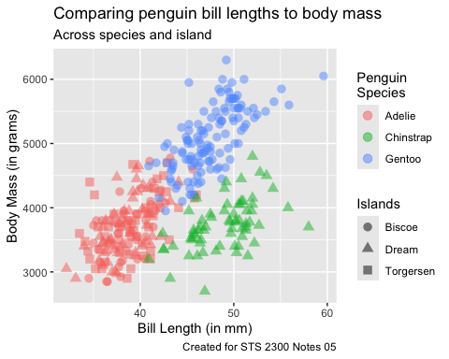

Notice how because I mapped species to color and island to shape there were legends created for both of those aesthetic elements. By default, the legend title would be the variable name. I was able to use shape and color arguments inside labs() to change these labels. (Note: By adding \n as part of my color label, I was able to tell R to add a line break there.)

# Editing graph scales

There are a number of functions in the ggplot2 package that follow the format: scale_xx_yy where xx is an aesthetic element like color, fill, shape, etc. and yy is a word like continuous, discrete, or manual.

Suppose that I didn’t care for the three shapes that were used in my graph above. I could add scale_shape_manual() and choose those shapes using the list of shape values from Notes 04.

graphA +  
 scale_shape_manual(values = c(8, 18, 25))

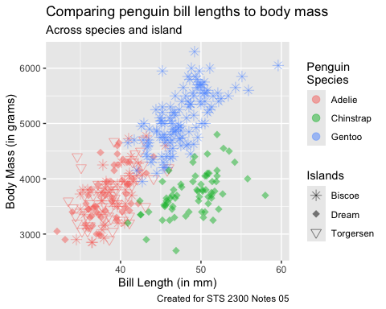

We could also do this with scale_color_manual() to change the colors.

**Practice:** Try using the example above to add a layer to your graph with scale_color_manual() that changes the colors of our three penguin species. You will still use the values argument to do this. Pick whichever three colors you prefer.

With aesthetic elements x and y, there are additional options for the part after the last underscore. For example, I may want to convert a numeric variable to the log (or square root) scale. Below is an example using the diamonds data. The graph on the left does not use a scale function. The graph on the right adds scale_x_log10().

library(patchwork)  
left <- ggplot(diamonds, aes(x = price)) +  
 geom_histogram(color = "white", bins = 20, boundary = 0)  
right <- left +  
 scale_x_log10() +  
 labs(x = "Price on log scale")  
left + right

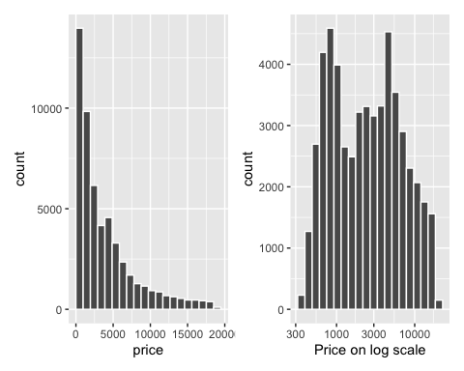

**Question:** How is the log scale transforming the way the data is displayed? In other words, what does it mean to put data on a log scale?

**Answer:**

Within these functions, we can tell R to reformat our axis values by adding commas in longer numbers, adding dollar signs to values that represent money, or converting proportions to percentages. Let’s do two of those for our diamond price graph (commas for our y-axis counts and dollar signs for our x-axis prices). I’ve also demonstrated how breaks can be used to change which values are displayed on our axes.

left +  
 scale_x_continuous(labels = scales::label_dollar()) +  
 scale_y_continuous(labels = scales::label_comma(),  
 breaks = seq(0, 15000, 2500))

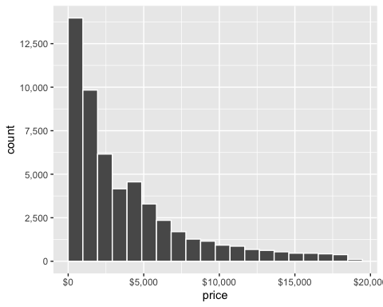

**Question:** What do you think the seq() function is doing here? What’s another way we could have written our code for that argument? (Hint: It uses the shortest function name we’ve learned)

**Answer:**

With categorical data, you may want to re-order the categories on your graph. For example, if I make a boxplot of majors using the MTH/STS Department majors data, the default is to plot the majors in alphabetical order (Applied_Math, Data_Analytics, Math, Stats). If I want to group the two math majors together and the two data majors together, I can do this using the limits argument.

majors <- read.csv("https://raw.githubusercontent.com/nbussberg/STS2300-Fall2024/refs/heads/main/Data/MTH_STS_majors_long.csv")  
  
ggplot(majors, aes(y = Major, x = Count)) +  
 geom_boxplot(fill = "gold", color = "maroon", alpha = .5) +  
 geom_point() +  
 scale_y_discrete(limits = c("Math", "Applied_Math", "Data_Analytics", "Stats"))

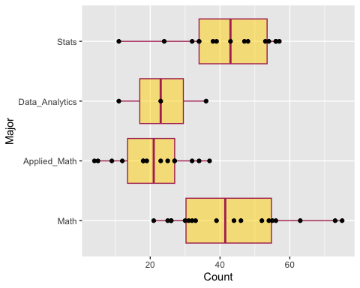

The limits argument can be used to order legends for color, fill, etc. as well.

**Question:** What else did I do with this graph that we haven’t seen before? Why might this be useful?

**Answer:**

# Color schemes and graph themes

We saw above that we can use scale_color_manual() or scale_fill_manual() to choose our own color schemes for the color or fill aesthetics. There are also **lots** of schemes others have created that we can choose from. One popular option is the scale_xx_viridis_yy series where xx is either color or fill and yy is either c (for continuous, aka quantitative) or d (for discrete, aka categorical). Within these functions is an argument called option that can take a letter from “A” to “H” as its value. Each of these is a different color-blind friendly color scheme that will also be readable when printed in black and white.

**Practice:** Try adding the appropriate one of these functions to our penguin scatterplot at the very top. Then choose an option you like.

**Practice:** Add the appropriate function to the graph below and choose an option you like. (Bonus: Edit the x and y axis labels, add commas to the y-axis, and change the values shown in the legend)

ggplot(penguins, aes(x = bill_length_mm, y =   
 body_mass_g,   
 color = flipper_length_mm)) +  
 geom_point(size = 3, alpha = 0.5)

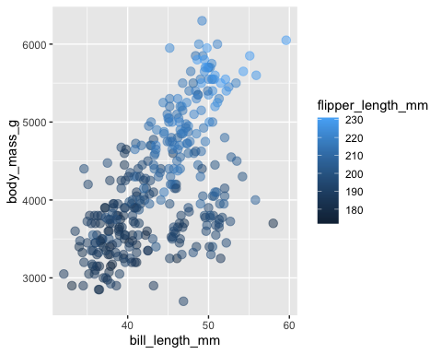

In Activity 04, we saw that we could add themes to our graph using theme_xx() where xx is one of the options from [here](https://ggplot2.tidyverse.org/reference/ggtheme.html). However, we may also want to customize our own themes. You can do this using the arguments in the theme() function.

[This website](https://henrywang.nl/ggplot2-theme-elements-demonstration/) contains a nice example of the elements of a theme that we can control. The picture below is from that site.

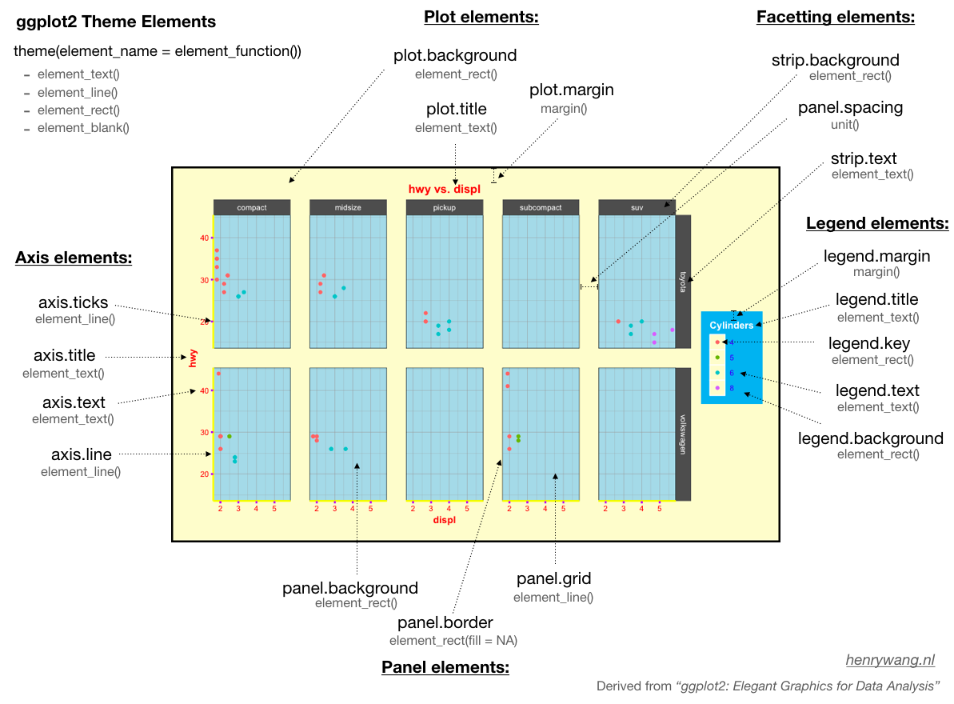

Suppose I want to create a theme I can add to graphs that uses Elon’s colors. Below is an example to illustrate possibilities for a few of these arguments using our data on MTH/STS Department Majors. (Note: This theme could certainly be improved, but the goal here is to demonstrate many different ways to change elements of a graph’s theme.)

ggplot(majors, aes(x = Year, y = Count, color = Major)) +  
 geom_line(linewidth = 2) +  
 geom_point() +  
 labs(title = "Elon MTH/STS Department Majors",   
 x = "Year (Fall Semester)",  
 y = "Number of Majors") +  
 scale_x_continuous(breaks = seq(2007, 2023, 3)) +  
 theme(plot.background = element_rect(fill = "firebrick4"),  
 panel.background = element_rect(fill = "white"),  
 panel.grid = element_line(color = "lightgray"),  
 plot.title = element_text(color = "goldenrod1",   
 size = 18,   
 face = "bold",   
 family = "Courier"),  
 axis.title = element_text(color = "goldenrod1",   
 size = 14),  
 axis.text = element_text(color = "goldenrod1"),  
 axis.ticks = element_line(color = "goldenrod1"),  
 legend.background = element_rect(fill = "darkgray"),  
 plot.margin = margin(20, 20, 20, 20))

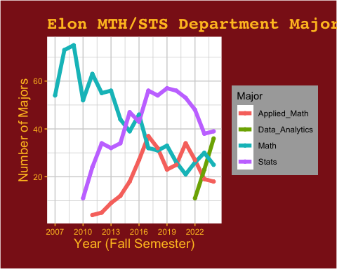

# Images with multiples graphs

In Activity 04, you saw how you could use facet_wrap() or facet_grid() to create multiple graphs of the same type that are separated across levels of variables. In other instances, you may want to combine other graphs into a single image. This can be done with the patchwork package. To use this package, we assign our graphs to objects in our environment (like I did at the top of this document for the penguins graph stored as graphA). Then we can combine these objects into one image using + to put them side-by-side or / to stack them. We can also combine these two features.

For example, below I make three graphs with the penguins data and then combine them into a single image. Notice how I can use the plot_annotation() packages similar to how I’ve used labs() if I want to add a title, subtitle, and caption to the combined plots rather than to individual plots.

library(patchwork)  
  
A <- ggplot(penguins, aes(x = bill_length_mm)) +  
 geom_histogram(binwidth = 5, color = "white")  
B <- ggplot(penguins, aes(x = bill_depth_mm)) +  
 geom_histogram(binwidth = 2, color = "white")  
C <- ggplot(penguins, aes(x = body_mass_g, y = species)) +  
 geom_boxplot(aes(fill = species),   
 show.legend = FALSE)  
  
(A + B) / C +  
 plot_annotation(title = "My Three Penguin Graphs",  
 subtitle = "Two histograms and side-by-side boxplots",  
 caption = "Made with the patchwork package")

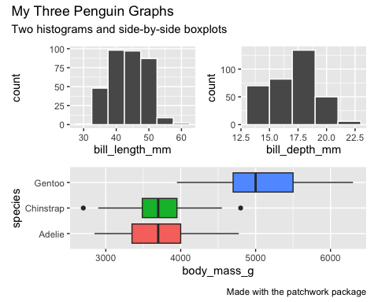

**Note:** Notice that I was able to remove the legend for the boxplots using a show.legend = FALSE argument. This is a good idea for a graph like this because the fill argument is already mapped to labels on the y-axis, so the legend wouldn’t be adding any new information.

**Practice:** Choose a dataset to explore. Create at least three graphs (with at least one using scale and theme options) and combine them in a different arrangement than we did above. Add an overall title.

# Revisiting the Learning Goals for Notes 05

* Be able to customize graph titles, captions, and variable labels.
  + Update this graph from Notes 04 to include an appropriate title. Change the color legend to say “Diamond Cut”. Add a caption saying “Made by __” with your name in the blank.

ggplot(data = diamonds) +  
 geom_bar(aes(x = cut,   
 fill = cut),   
 color = "black")

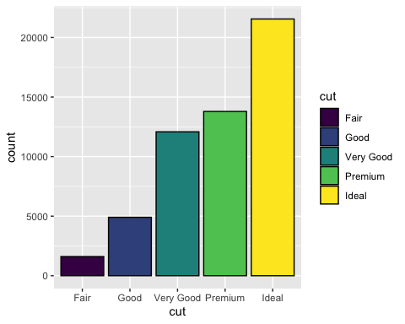

* Be able to edit the scales of your graphs to improve the visual appeal and to better convey information.
  + Add commas to the y-axis values.
* Be able to customize color schemes and aspects of a graph’s theme
  + Choose a new color scheme for the fill of the bars using an appropriate function. Create a custom theme that changes at least three elements of the graph (e.g. panel background, plot background, panel grid, axis text, etc.)
* Be able to create images containing multiple graphs (using facetting or by combining separate graph objects)
  + Create a second graph that shows a histogram of diamond price facetted by cut. Then combine your new graph and the previous bar graph into a single image using the patchwork library. Add an overall title to this new image.